My take on the @Kaggle 2021 Data Science and Machine Learning survey with a focus on Nigerian Kagglers - <https://www.kaggle.com/adeayosotayo/2021-kaggle-survey-a-focus-on-nigerian-kagglers>

Here are some important takeaways:

#DataScience #Kaggle #MachineLearning

* The top three countries are **India**, **USA** and **Japan**.
* In comparison to other countries, **Nigeria Kagglers make up about 2.7%** and **Nigeria ranks 7th.**

* Out of the 64 countries that took part in the Kaggle Survey, 10 countries are from Africa.
* Within Africa, **Nigeria Kagglers** make up 34% and **ranked number one in Africa**.
* The top three African countries on Kaggle are **Nigeria**, **Egypt** and **Kenya**.

* The total number of responses for the 2021 Kaggle Survey from **Nigeria** was 702.
* There has been a steady growth in the number of responses over the past five years.
* The number of responses from Nigerian Kagglers in **2021** is about **10 times greater** than in **2017**.

* **15%** of **Nigerian Kagglers** are **women** and **85%** are **men**. This reflects a **large gender gap** among Nigerian Kagglers.
* Compared to the rest of the world, the percentage of female Kagglers in Nigeria (15%) is **lower** than the rest of the world (19%).

* Most Nigerian Kagglers are **Students**, **Data Analysts** and **Data Scientists**.
* Apart from students, the **job titles** for most Nigerian Kagglers are **Data Analysts**, **Data Scientists** and **Software Engineers**.

* The **largest proportion (30%)** of Nigerian Kagglers are in the age range of **25 - 29**.
* About **65% of Nigerian Kagglers** are within the age of **22 - 34**.
* **91%** of Nigerian Kagglers are **younger** than **40**.

Most Nigeria Kagglers work in the following sectors:  **Academics/Education**, **Computers/Technology**, and **Accounting/Finance**.

How much do Nigerian Kagglers earn?

* Almost half of Nigerian Kagglers (45 percent) **earn less than $1,000 per year**.
* About **60% of Nigerians** earn less than $2,000 per year.

What programming languages do Nigerian Kagglers use?

* The **top programming language** for Nigerian Kagglers is **Python**, which is similar to the rest of the world.
* Most Nigerian Kagglers use **Python, SQL and Javascript**.

* **Jupyter Notebook** is the **most popular IDE** among Nigerian Kagglers and the rest of the world.
* Similarly, the three most popular IDEs among Nigerian Kagglers and the rest of the world are **Jupyter Notebook, VScode and PyCharm**.

Top three machine learning frameworks:

* **Scikit-learn**
* **TensorFlow**
* **Keras**

Top three Machine Learning algorithms used by Nigerian Kagglers

* **Linear/Logistic Regression**
* **Decision Trees/Random Forests**
* **Gradient Boosting Machines(XGBoost, lightgbm, etc)**

Top three databases used by Nigerian Kagglers

* **MySQL**
* **PostgreSQL**
* **Microsoft SQL Server**

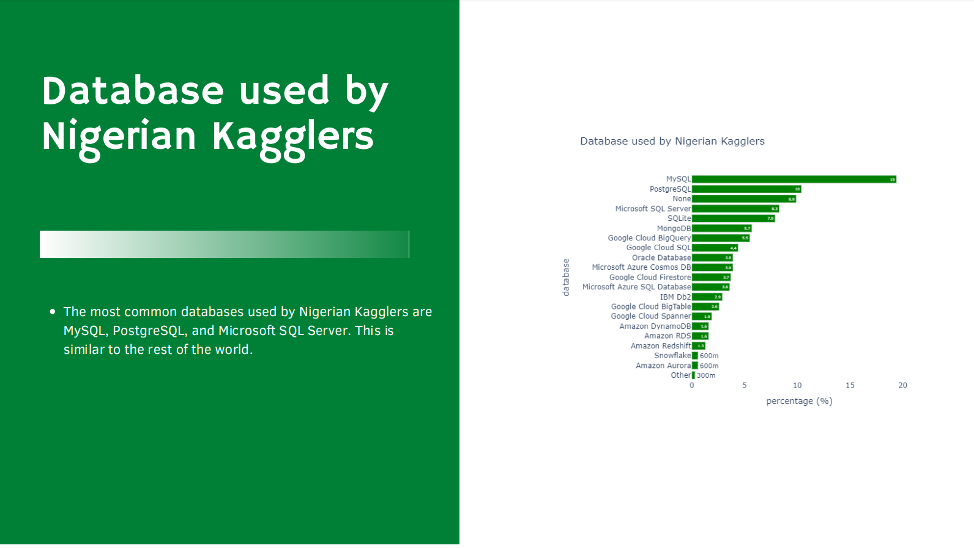

An **executive summary** of this work is available here - <https://www.drsotayo.com/wp-content/uploads/2021/11/2021-Kaggle-Survey-A-focus-on-Nigerian-Kagglers.pdf>

Thanks for reading.

#DataScience #Kaggle #MachineLearning